Ideation Phase
Define the Problem Statements

Date | 08 October 2026
Team ID: | SWUID2026235621
Project Name | iMovies - Cinema Booking Platform
Maximum Marks | 2 Marks

Customer Problem Statement Template:
To define the primary challenges and emotional frustrations moviegoers encounter when discovering films, selecting preferred seats in real-time, and completing bookings online, and to use these verified user insights to guide the technical design of the iMovies platform.
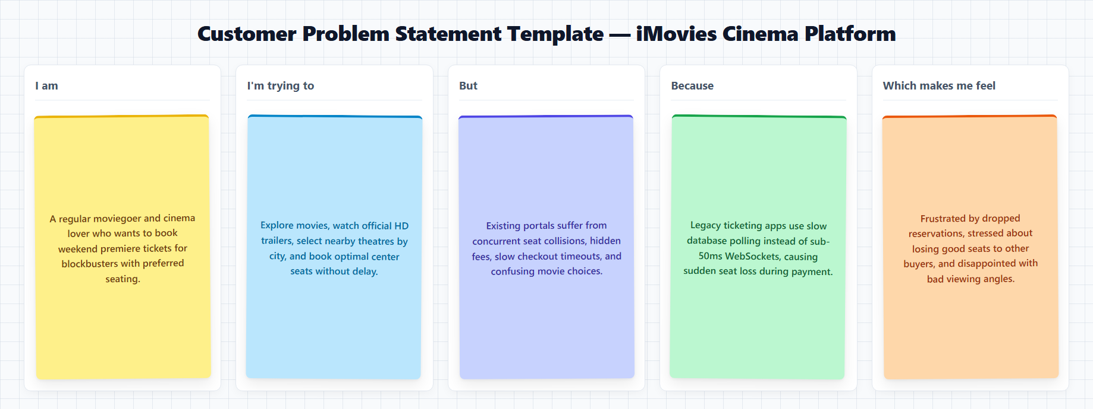
Reference: https://miro.com/templates/customer-problem-statement/

Problem Statement (PS) | I am (Customer) | I’m trying to | But | Because | Which makes me feel
PS-1 | College student and weekend moviegoer. | reserve prime weekend cinema tickets together with friends for blockbuster releases | seats get unexpectedly locked or conflict during checkout, causing payment failures and lost bookings | traditional ticketing portals lack instantaneous live WebSocket seat synchronization during high-traffic rushes | deeply frustrated by lost seats and forced to settle for separated or front-row seats.
PS-2 | Working professional planning family cinema outings. | quickly discover high-rated movies nearby, preview official trailers, and select convenient showtimes, | existing ticketing apps have cluttered, ad-heavy interfaces with broken trailer links and no curated guidance |  | I spend over 20 minutes jumping between apps and often pick disappointing movies.

